Support AMM's Simulated Strategies Hub™

First and foremost...
Thank you.
Simply taking the time to read my guides, provide feedback, or share this project with others is already a tremendous way to support its growth.
Cryptotized Gameplay™ began as a personal passion project driven by a simple question:
"What if video games could become platforms for learning, strategic thinking, and collaborative storytelling?"
Today, that vision continues to grow through community feedback and shared creativity.

The Best Ways to Support
You don't have to donate to make a difference.
You can support this project by:
⭐ Starring the GitHub repository
📢 Sharing the guides with friends
🐛 Reporting bugs or inconsistencies
💡 Suggesting new ideas
🎮 Testing campaigns
✍️ Creating community guides
❤️ Following the project on social media
Every contribution helps improve Cryptotized Gameplay™.

Financial Support
If you would like to support future development financially, any contribution is sincerely appreciated.
Donations help support:
- Website hosting
- Domain registration
- AI development tools
- Artwork
- Community infrastructure
- Future guides
- New features
Every donation goes directly toward improving AMM's Simulated Strategies Hub™.

Cashapp (Recommend)

$mendezangel6

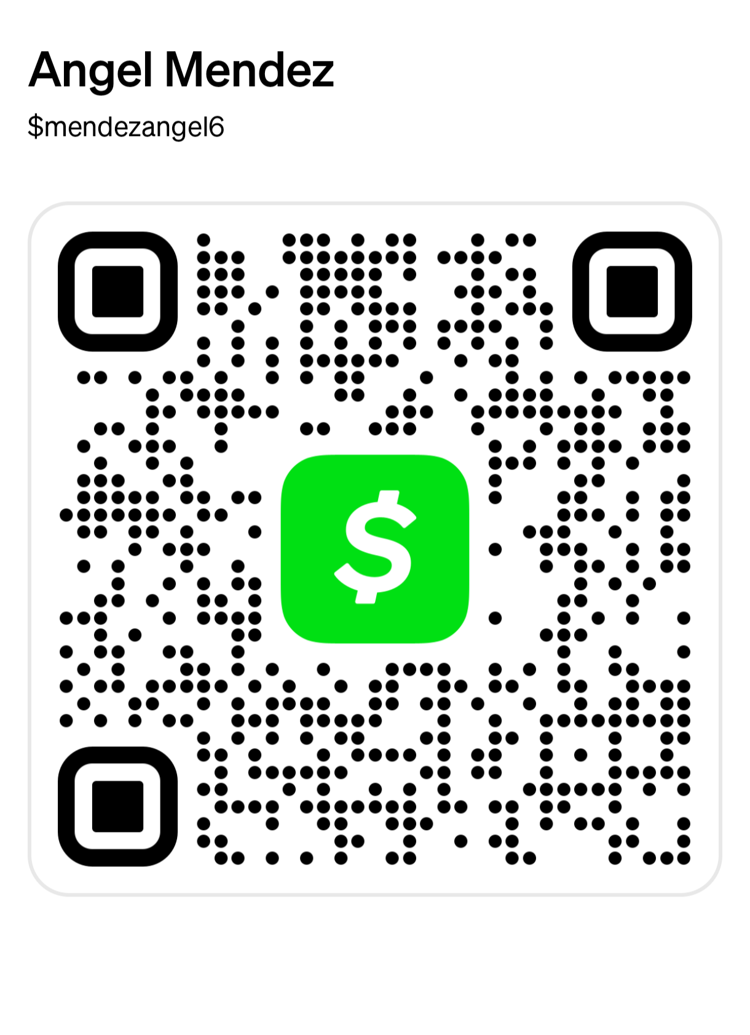

Coinbase
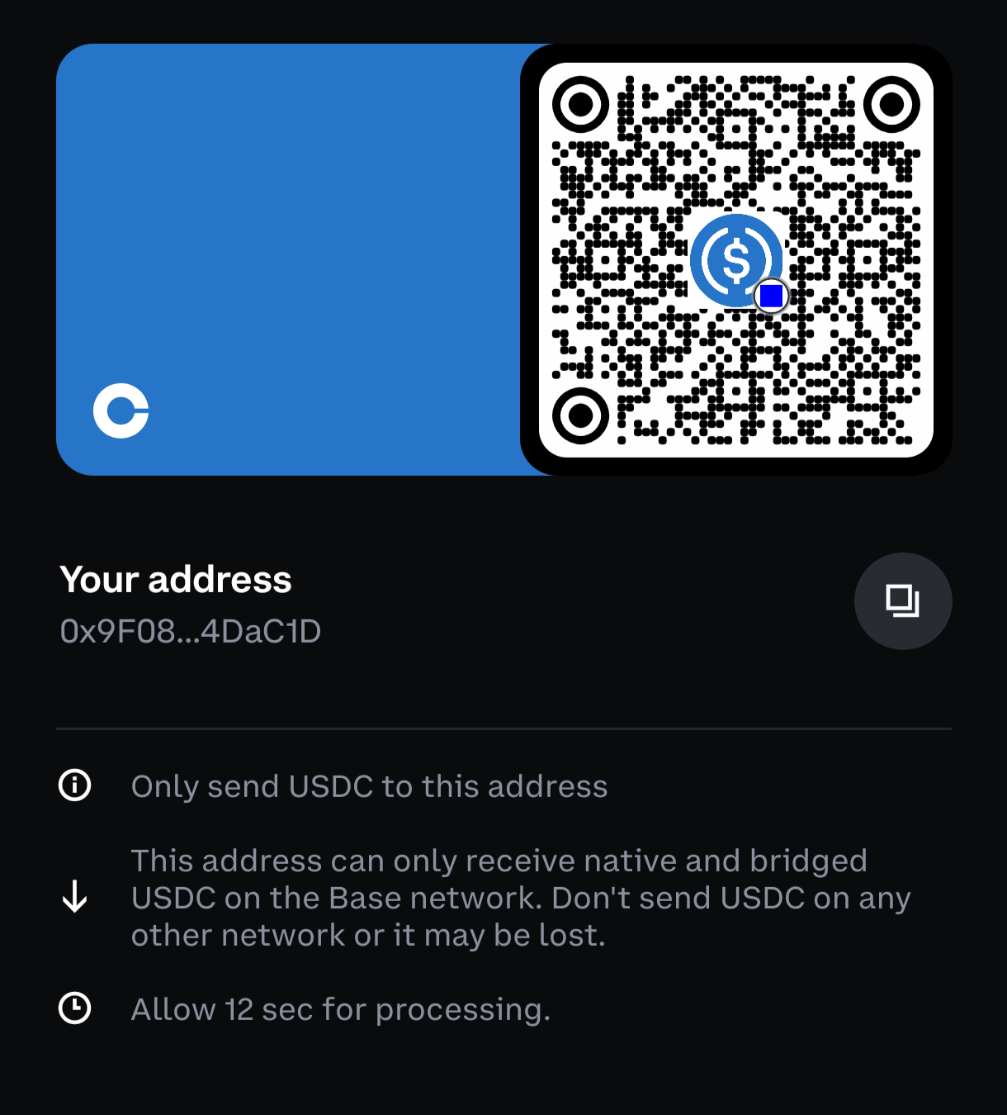

USDC Base Address (Recommend)

0x9F08f0E165a521B9f772910B4f833e34D84DaC1D

This is a Base network address. Do not send USDC over any other network to this address or your funds may be lost.

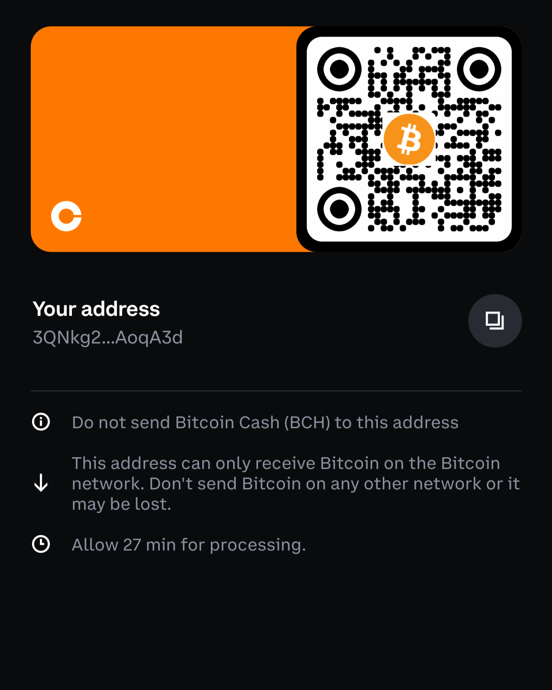

Bitcoin BTC Address

3QNkg2wfYcd9oog2QFoBQLArKjkzAoqA3d

Do not send Bitcoin Cash (BCH) to this address
This address can only receive Bitcoin on the Bitcoin network. Don't send Bitcoin on any other network or it may be lost.
Allow 27 min for processing.

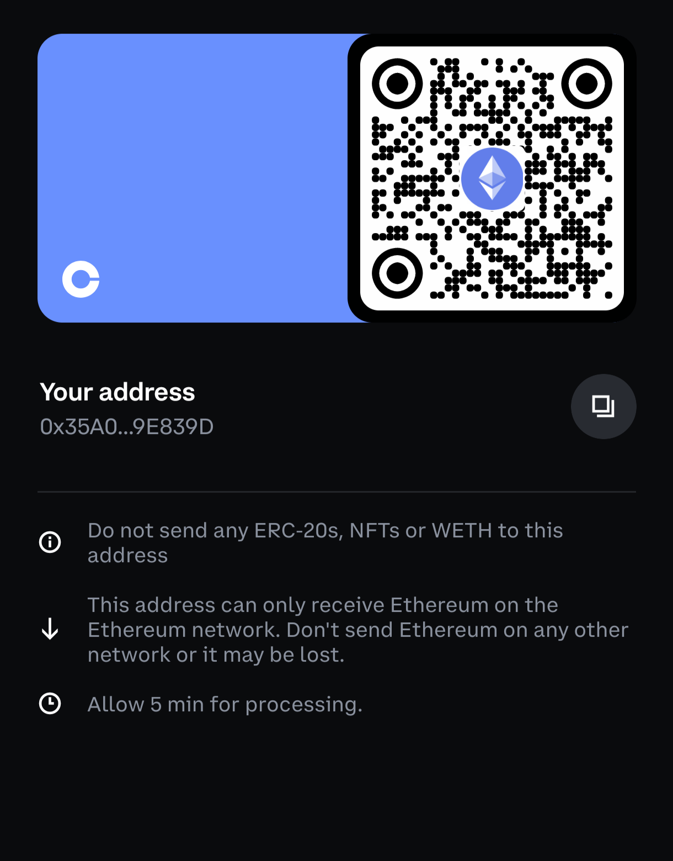

Ethereum ETH Address

0x35A019b5A11bD9b5365dB7F560BFf5F0749E839D

Do not send any ERC-20s, NFTs or WETH to this address
This address can only receive Ethereum on the
Ethereum network. Don't send Ethereum on any other network or it may be lost.
Allow 5 min for processing.

Transparency
At this stage, Cryptotized Gameplay™ is an independent passion project.
There are:
- No paid subscriptions.
- No advertisements.
- No paywalls.
Your support simply allows me to dedicate more time to creating new guides, improving existing ones, and expanding the community.

Future Goals
My long-term vision includes:
- 🌐 A fully interactive website
- 🤖 AI-powered campaign management apps
- 🎮 Multiplayer campaign support
- 📚 Hundreds of community-created guides
- 🏆 Contributor recognition system
- 🤔 Branch out and explore other possibilities
Every contribution brings us one step closer.

Thank You
Whether you donate, contribute a guide, report an issue, or simply enjoy these projects...
Thank you for being part of Season Zero.
You're helping build something I've dreamed about for a long time.

The End

It's been an amazing journey!!!

I’m very excited and pleased with all the research and development that has been put into these roleplaying projects. It wasn’t easy but the results are a spectacle. I had a tremendous amount of fun creating my guides and I truly hope you do two. There’s just something truly amazing when people come together and try out different approaches to your favorite games.

Imagine creating something so well written that it just flows perfectly with your roleplay, like if the game was tailored to you…. Remember, nothing is perfect and sometimes technology can be a pain in the ass. However, as time gets better so does technology and the way we do things. Today there are guides, tomorrow there could be something even more spectacular to marvel….

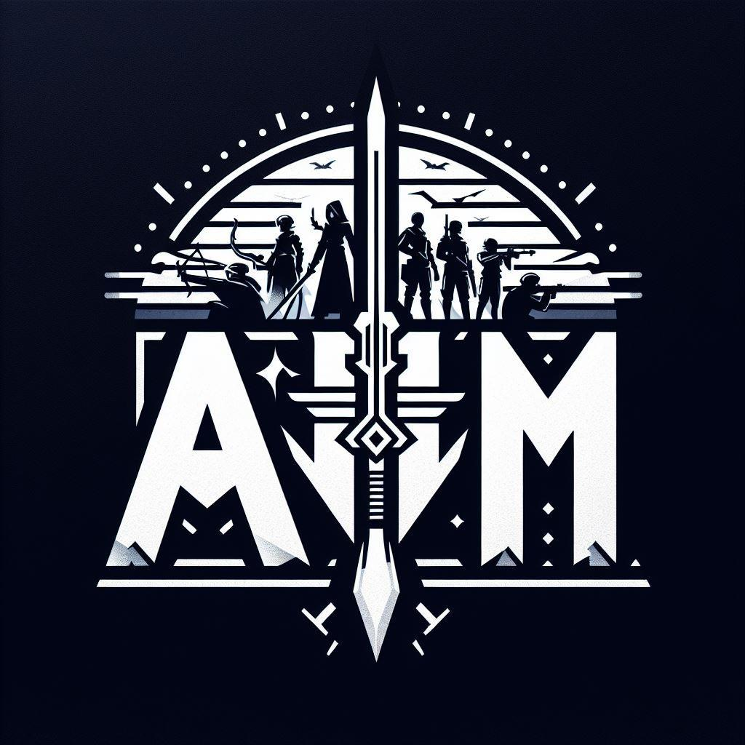

AMM's Simulated Strategies Hub™
Copyright © 2026 Angel Mendez. All Rights Reserved.

